Networking III

Jamie Dempsey – C00295144@setu.ie

Project: National Children’s Hospital (NCH)

Introduction
This project focuses on designing and implementing a secure, scalable network for the National Children’s Hospital (NCH). The network spans multiple sites and supports a wide range of users, including IT staff, Admin, HR, Medical teams, Researchers, and guests. Each group has different access requirements, so the network must separate traffic, control access, and ensure that critical services such as email, web hosting, VPN, and wireless connections remain available and protected.
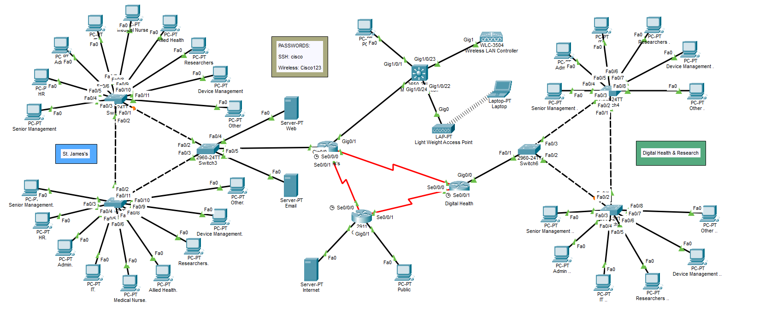

Step 1. The Local Area Network (St. James’s)
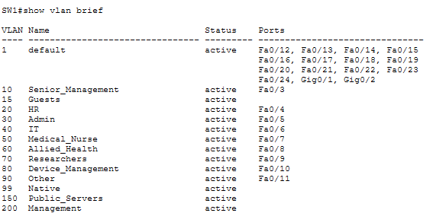
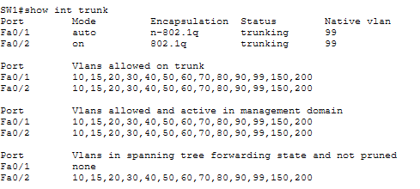

Step 1. The Local Area Network (Digital Health & Research)
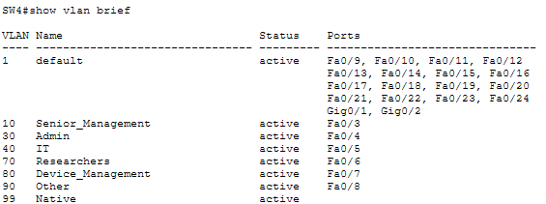
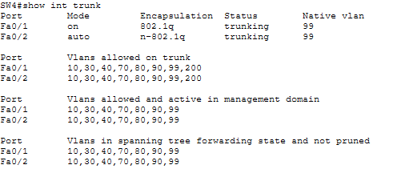

Step 2. IPv4 Addresses (St. James’s)
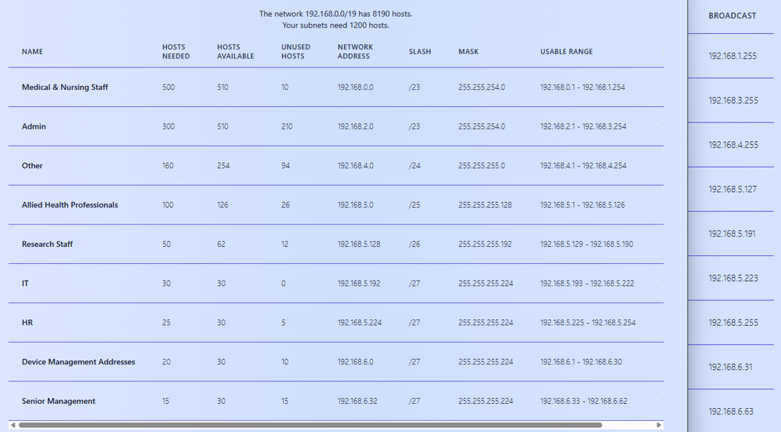
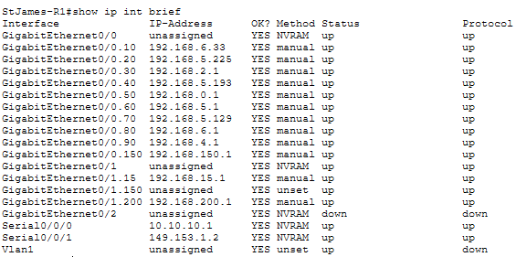
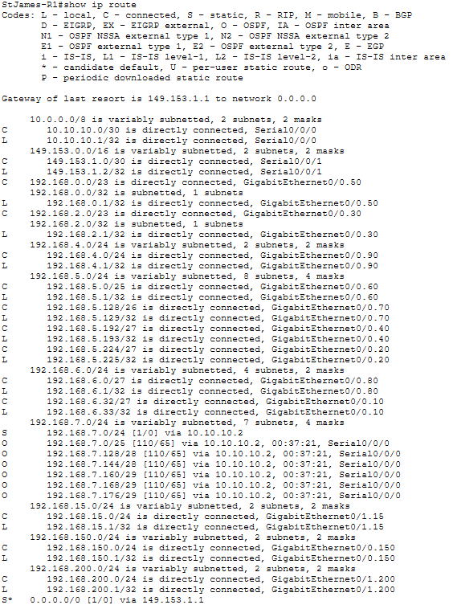

Step2. IPv4 Addresses (Digital Health & Research)
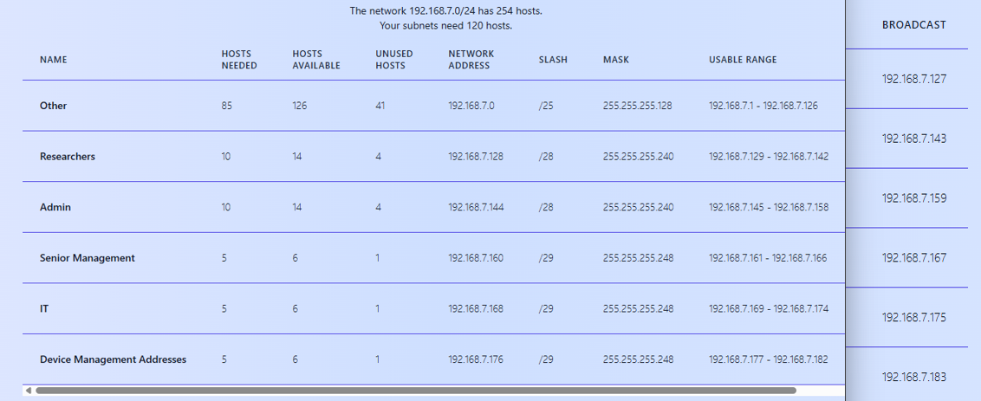
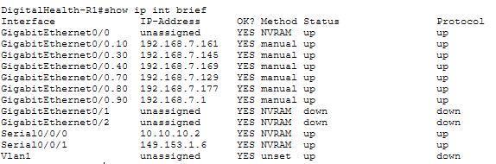
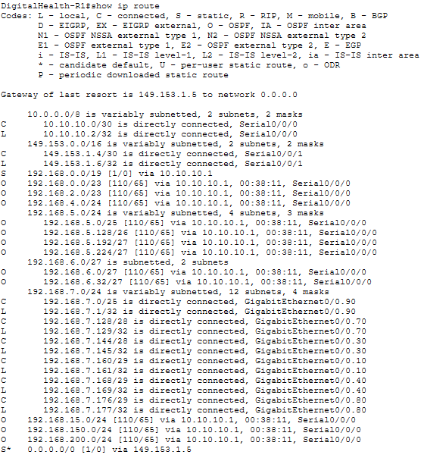

Step 3. Wireless
Purpose: Demonstrates the WLC settings for the Guest WLAN
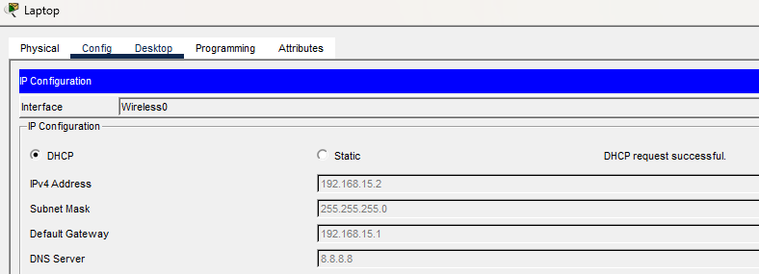
Purpose: Confirms the AP has joined the WLC and is broadcasting the Guest WLAN.
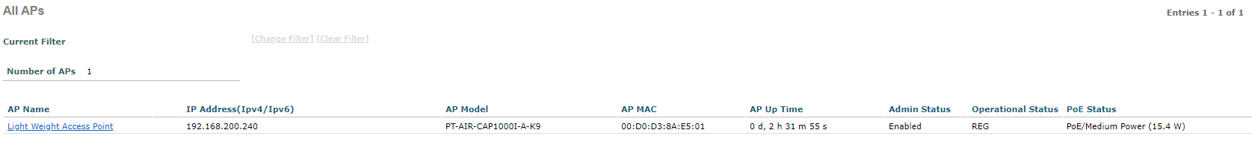
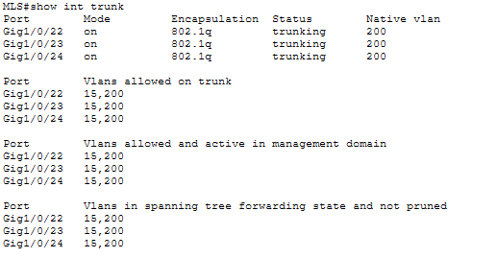
Purpose: Shows a wireless device successfully receiving a DHCP lease from the WLC.
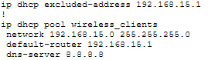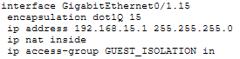
Purpose: Proves the Guest WLAN can access the network and reach external services.
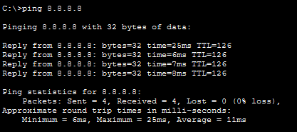
Purpose: Proves the Guest WLAN is isolated from internal networks.
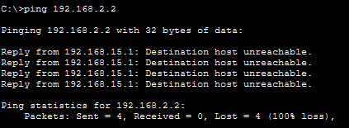
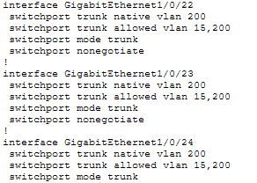

Step 4. NAT/PAT (St. James’s)
Purpose: NAT inside/outside interface and static NAT entries for Web/Email servers.
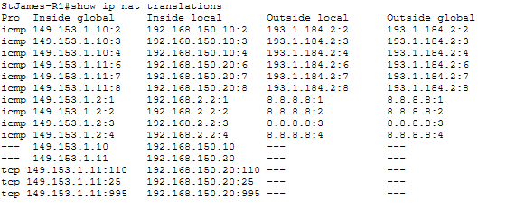
Purpose: Shows active NAT translations, proving that NAT/PAT is functioning properly.
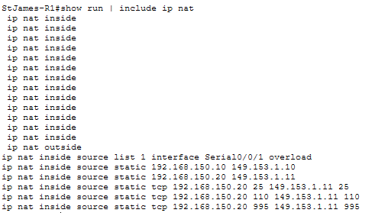

Step 4. NAT/PAT (Digital Health & Research)
Purpose: Confirms configuration of NAT/PAT for internal clients at Digital Health
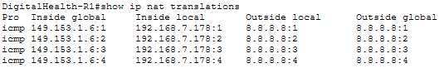
Purpose: Verifies PAT translations, showing internal hosts accessing the Internet.
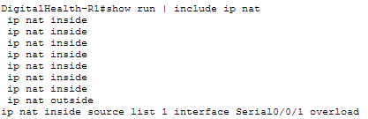

Step 5. VPN (St. James’s)
Purpose: Shows ISAKMP policy, transform set, and crypto map for VPN configuration.
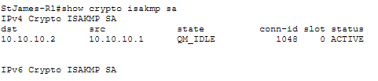
Purpose: Confirms IPsec tunnel establishment and traffic flow between sites.
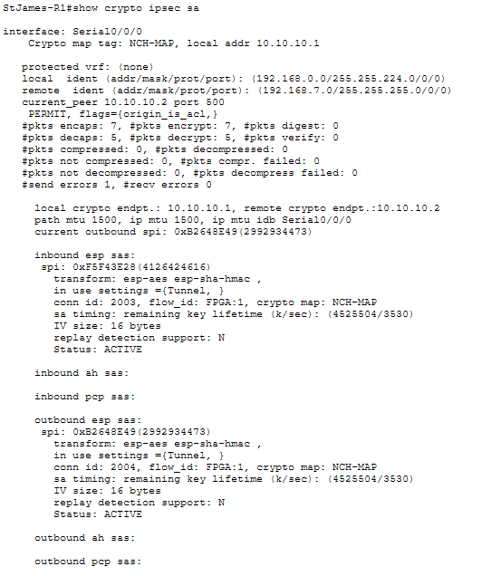

Step 5. VPN (Digital Health & Research)
Purpose: Shows the matching VPN configuration for the Digital Health router.
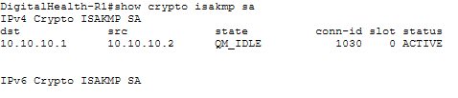
Purpose: Confirms IPsec tunnel establishment and traffic flow between sites.
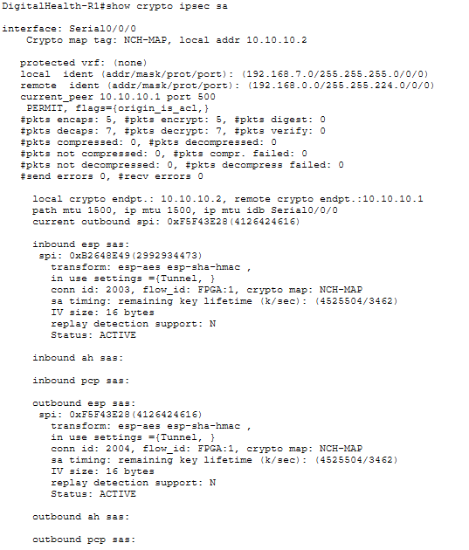

Step 6. SSH / ACLs (St. James’s + Digital Health & Research)
Each access list was tested using end-devices assigned to the relevant VLANs.
Testing included ping, telnet, and web access, depending on the ACL’s purpose.
A screenshot of show access-lists was captured after each test to show the ACL counters increasing, proving that the deny/permit rules were triggered correctly.

Purpose: Only IT staff can SSH into network devices.
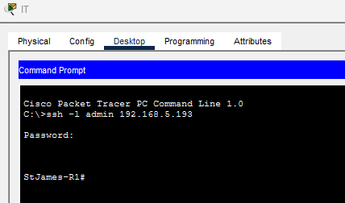
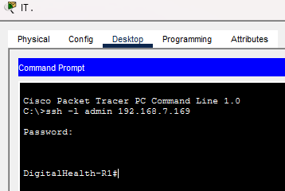
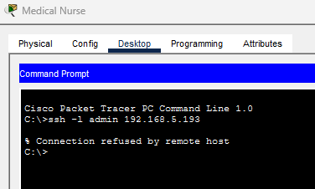
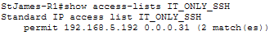
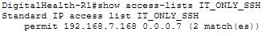
Purpose: Admin can only access email + web servers, and the Internet.
All other internal VLANs must be blocked.
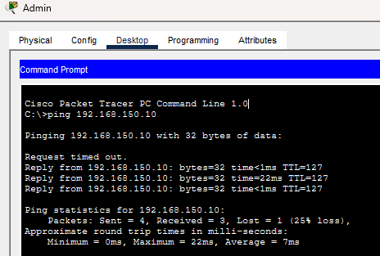
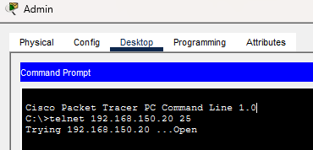
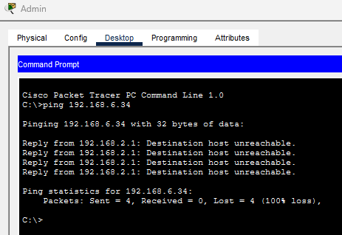
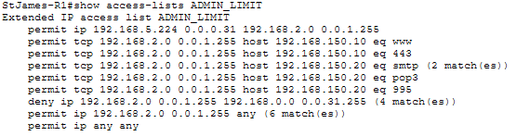
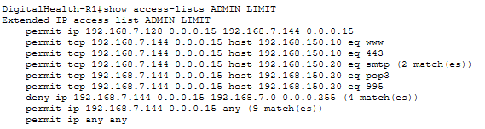
Purpose: HR can access all VLANs, but no other VLAN may access HR PCs.
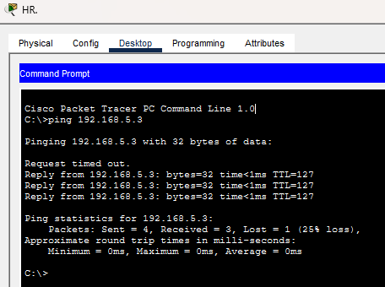
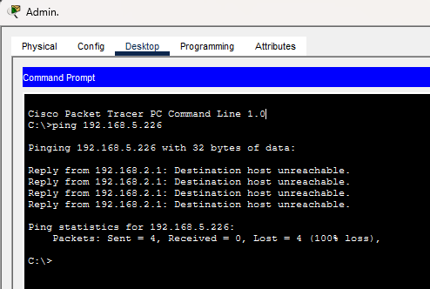
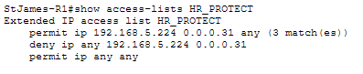
Purpose: Allow Internet users to access Web & Email servers only.
Block access to internal VLANs.
